Introduction to Statcato
Statcato is a free, open-source software application designed for elementary statistics. It provides statistical tools for computations commonly performed in introductory statistics courses. It is developed in Java and therefore can be used on various operating systems, including Microsoft Windows, Mac OS X, Linux, and Solaris. Details on how to obtain a copy of Statcato are available at http://www.statcato.org/download.html.
This chapter explains the interface and basic operations of Statcato, such as inputting data, saving files, and printing. Be sure to read this chapter before doing the subsequent lab activities.

Student Learning Outcomes
By the end of this chapter, you should be able to do the following in Statcato:
- Recognize different components of the application interface
- Input, edit, load, and save data
- Save and open projects
- Get help

Getting to Know the Interface
The interface of Statcato (Figure 1) consists of the following components:
- Log window: shows the results of computations
- Data window: contains sheets in which data values can be entered, edited, and manipulated using various tools
- Dialog history window: shows and allows quick access to a list of recently used items
- Menus: provides access to all the tools available
  - File: open new or saved projects/datasheets, clear or close windows, load datasets, print files, edit application options
  - Edit: edit log and datasheets, edit last dialog, show dialog history
  - Data: manipulate data, generate patterned or random data
  - Calculate: compute probability distributions, p-Values, and frequency table; calculator
  - Statistics: descriptive statistics, sample size determination, confidence intervals, hypothesis tests, correlation and regression, multinomial experiments, and analysis of variance, nonparametrics
  - Graph: bar chart, box plot, dot plot, histogram, normal quantile plot, pie chart, scatterplot, stem-and-leaf plot
  - Windows: log, data, dialog history, and generated graphs
  - Help: help menu, information, check for updates
- Toolbar (Figure 2): provides shortcuts to commonly used tools
- New Datasheet: Open a new datasheet in the Datasheet window.
- Open: Open a saved log if the log window is selected. Open an existing Datasheet if the datasheet window is selected.
- Save: Save the log window if the log window is selected. Save the datasheet if the datasheet window is selected.
- Import: Load a built-in dataset or one from a web address.
- Print: Print the log window if it is selected. Print the active datasheet if the datasheet window is selected.
- Cut.
- Copy.
- Paste.
- Undo.
- Redo.
- Edit Last Dialog: Bring up the most recently used dialog.
- Dialog History: Show a history of the most recently used dialog.
- Help: Display the documentation.
- Status: displays program status and hints
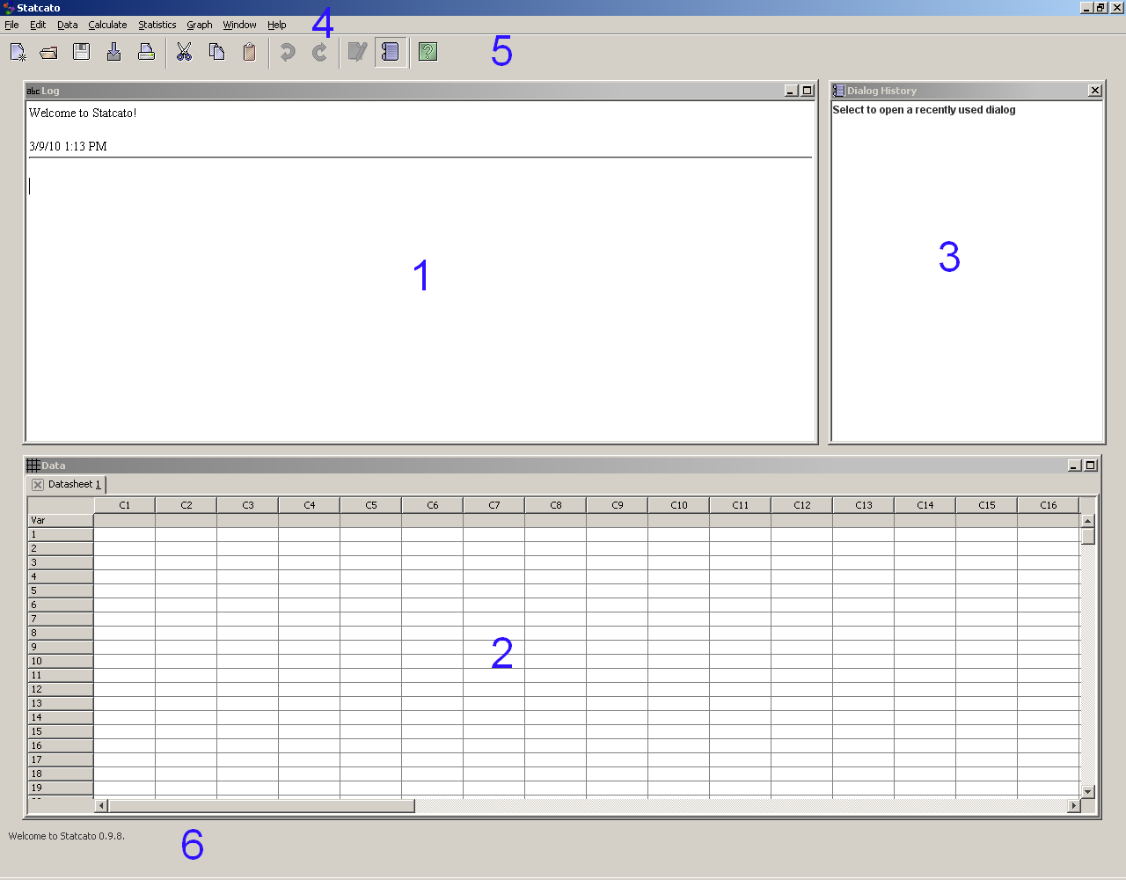
Figure 1 Application interface
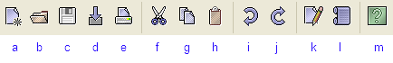
Figure 2 Toolbar
If you prefer using the keyboard to access menus, press the Alt key to see the access keys assigned to the various menu items (the key is the letter underlined, e.g. File). Here are keyboard shortcuts of commonly used items:
File  New Datasheet  Ctrl-N  Open Datasheet  Ctrl-O  Save Current Datasheet  Ctrl-S  Print Log Window  Ctrl-P  Exit  Alt-F4 | Edit  Undo  Ctrl-Z  Redo  Ctrl-Y  Cut  Ctrl-X  Copy  Ctrl-C  Paste  Ctrl-V  Select All  Ctrl-A  Clear  Backspace  Delete  Delete | Help  Help Menu  F1  About  F2

Inputting, Editing, Loading and Saving Data
You can organize data in datasheets. Cells in a datasheet can contain both text and numbers. Numbers in a datasheet are displayed to at most six decimal places. The tooltip of a cell shows the precise value stored in a cell. The Var (variable) row of the datasheet is for the variable names of the columns. The column names are composed of the letter ‘C’ and the column numbers (e.g. C1). The row names are simply the row numbers (e.g. 1).
To enter a data value into a cell, select the cell, type in the value, and press Enter.
Datasheets are shown in tabs in the Data window. To add a new datasheet, go to File > New Datasheet or use the shortcut Ctrl+N.
By default, a datasheet has 300 rows (1, 2, …, 300) and 50 columns (C1, C2, …, C50). You can add multiple rows and/or columns by going to Edit > Add Multiple Rows/Columns.
You can edit (e.g. copy, paste, delete, insert) using the Edit menu or through context menus that are shown when you right-click on a selected item.
Statcato supports data files of Microsoft Excel (.xls), comma-separated values (.csv), and tab-delimited text (.txt) formats. You can open a datasheet using the dialog File > Open Datasheet.
Statcato comes with a number of built-in datasets. You can load a built-in dataset or a dataset on the Internet using File > Load Dataset (Figure 3). To load an online dataset, in the Load Dataset dialog enter the web address (URL ) of the dataset and select the file type.
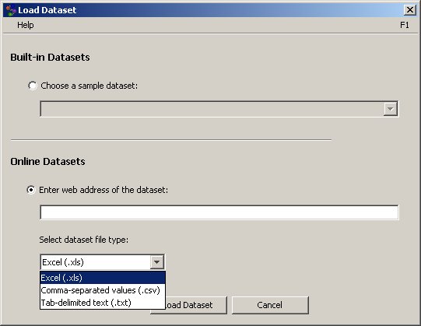
Figure 3 Load dataset
You can save the active datasheet through File > Save Current Datasheet or save it as a new file through File > Save Current Datasheet As.

Saving and Opening Projects
A project stores the contents of the log window, datasheets, and charts. To save the currently opened datasheets, log window, and charts as a project, go to File > Save Project. A Statcato project file has a file extension of .stc. To open a previously saved project, go to File > Open Project. To create a new project, simply close the current project (File > Close Project). You will be prompted to save if there are any unsaved contents.

Printing
To print the log window, use File > Print Log. In the Print Log dialog (Figure 4), you have the option of specifying the header and footer, which will be displayed at the top and bottom of each printed page, respectively.
To print the active worksheet, use File > Print Worksheet. In the Print Worksheet dialog (Figure 5), you can specify the print area, header, and footer. A print preview window will be shown, and you and choose to print or export the file to various formats (PDF, Excel, RTF, HTML, CSV, and text).
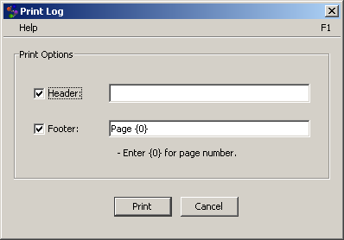
Figure 4 Print log
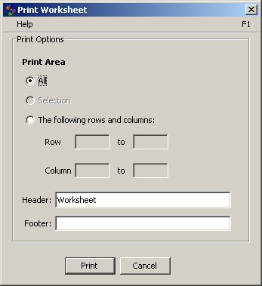
Figure 5 Print worksheet

Getting Help
To open the documentation for Statcato (Figure 6), you can go to Help > Help, press F1, or click the help button in the toolbar.
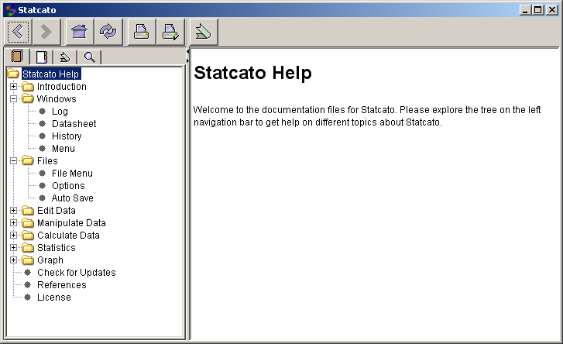
Figure 6 Documentation
You can also access help specific to a dialog by clicking the Help menu bar at the top of the dialog (Figure 7) or by pressing F1.
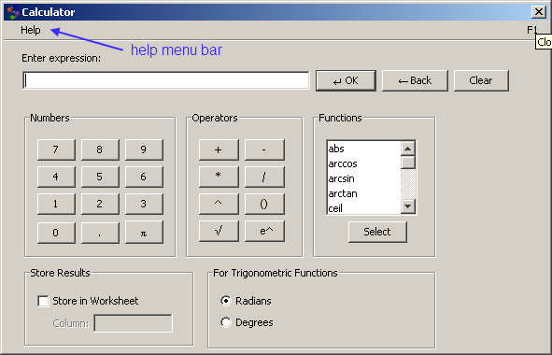
Figure 7 Help menu bar in dialog
If you need further help with Statcato, you can also post a question on the Statcato online forum (http://sourceforge.net/projects/statcato/forums). The developers of Statcato will do their best to help you. If you discover an error (or a bug) in Statcato, please report to the online forum so that the developers can include a fix of the problem in the next release.
You should now have a good basic understanding of Statcato and should be ready to venture into the lab activities exploring statistics. Enjoy!

